**Vignette**

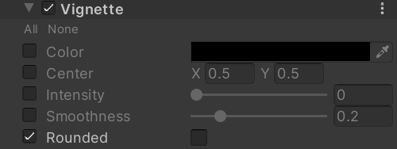

Color

Vignette color.

Center

Sets the vignette center point (screen center is [0.5,0.5]).

Intensity

Amount of vignetting on screen.

Smoothness

Smoothness of the vignette borders.

Rounded

Should the vignette be perfectly round or be dependent on the current aspect ratio?

How:

half3 ApplyVignette(half3 input, float2 uv, float2 center, float intensity, float roundness, float smoothness, half3 color)

{

    float2 dist = abs(uv - center) * intensity;

    dist.x *= roundness;

    float vfactor = pow(saturate(1.0 - dot(dist, dist)), smoothness);

    return input * lerp(color, (1.0).xxx, vfactor);

}